Did you know?
Your local pharmacist can help you with practical advice about your medicines such as how to manage potential side-effects, how to take your medicines effectively e.g. time of day or with food, inhaler technique.

Many remedies are available to purchase for self limiting minor ailments or without a prescription through the Pharmacy First Service.

Some sources suggest it costs the NHS, on average, £34 for each prescription, including e.g. Paracetamol, available to buy for less than £1. Medicines that are over-ordered and not used cost NHS Scotland around £15m each year. This is equivalent to 2,250 coronary bypass operations OR 1,800 hip operations OR 225,000 cataract operations

Excessive medicines at home may be a safety risk to you and others. The medicines may be out of date,
may no longer be appropriate for your medical condition or may lead to your taking too much medication.

As a patient or carer, you are the best person to order the correct amount of repeat medicines, as you can check what is needed before ordering.

If you lose your repeat prescription request slip, the Patient Care Adviser can print another for you.

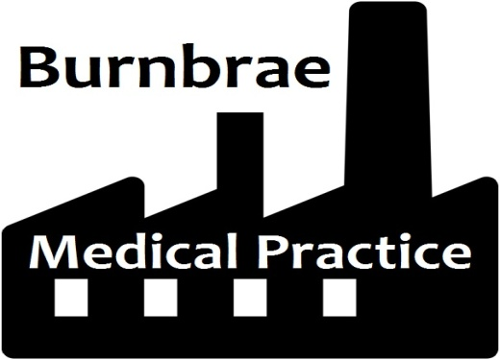

Repeat Prescriptions

A guide to the safe and effective use of your medication

Telephone:
01501 822256
01698 384482

www.burnbraemedicalpractice.co.uk

Following these simple steps will help make sure that you use your medicines safely, get the most out of them and help to prevent waste

Ordering you Repeat Prescriptions
Check what medicines you already have at home before you order so that you only order the medicines you need.

It is important not to stockpile medicines at home.

Repeat prescriptions can only be issued 7 days before they are due

Please use our on line ordering system. You can get the form to register for this service from Reception or via our website. Once completed bring the form back to the Practice Reception with photographic ID. Once we confirm your identity you will be issued with a secure user name and password. Requests can then be made securely through the link on our website at www.burnbraemedicalpractice.co.uk.

You can also deposit the order slip that came with your last prescription in the red box on the wall in Shotts Health Centre or you can hand it into your local Pharmacy. The chemist will deliver it to the Practice for processing.

Ordering medicines over the phone can lead to mistakes so please try to order them on line or using the re-order slip.
If you do need to telephone to request your repeat prescription please do so after 10.30am to allow easier access for patients who wish to arrange an appointment.

Hand in any hospital discharge prescriptions or hospital clinic prescriptions promptly to allow any changes to be made to your ongoing treatment and support.

Collecting your Prescription
Prescriptions will be available for collection at the Practice in 2 working days. If your prescription is being sent directly to the chemist from the Practice please allow at least 72 hours between the request for a prescription and collecting the medication.

Check your prescription before you leave the Pharmacy. You will generally be issued with 2 months supply of any regular treatment. If you realise you have ordered items that you don’t really need give them back to the Pharmacy prior to leaving. Once medicines have left the Pharmacy they cannot be recycled or used for someone else. Your prescription can be adjusted accordingly.

Any unused medicines can be returned to the Pharmacy for safe disposal. Never dispose of any unused or unwanted medicines down the toilet
Your medicine is prescribed for you and should not be taken by anyone else.
Store medicines in an appropriate place, out of the reach of children.
Reviewing your Medication
A medication review by your GP, Practice Nurse or Practice Pharmacist helps to make sure your medicines are still helping you. This is done routinely at least once every year usually in the month of your birth. This may coincide with other check-ups you may be invited to for any long-term conditions you may have.

Removing Medication from you Repeat Prescription
Your GP will remove any repeat medicines from your list which are not requested at the appropriate intervals for your safety.

If you do not respond to invitations to attend your GP, Practice Nurse or Practice Pharmacist to review your medication or carry out any necessary checks to ensure the safety and effectiveness of your medication it will be removed from your repeat prescription list and you will no longer be able to order it from the Practice in this way.

Let your GP or chemist know if you have stopped taking any medicines. Cross them out on your repeat prescription re-order form.

